  

**NAME : ZOHO BOOKS**

**PROJECT TITLE : ZOHO BOOKS FOR KEERTHI**

**SWEETS**

**PROJECT SUBMITTED : SMART INTERNZ**

**YEAR : III**

**DEPARTMENT : COMMERCE & CA**

**SEMESTER : V**

**GROUP ID : 17745**

**MEMBERS OF THE GROUP : S.SANJAI**

**R.SANJAY KUMAR**

**J.SANTHOSH**

**P.SANTHOSH**

**GUIDED BY : VAIRAMUTHUSELVI M**

**SPOC NAME : EZHIL VENDHAN R**

**PREPARATION MAINTANCE OF ZOHO BOOKS FOR KEERTHI SWEETS**

**STEP 1**

CREATED A COMPANY

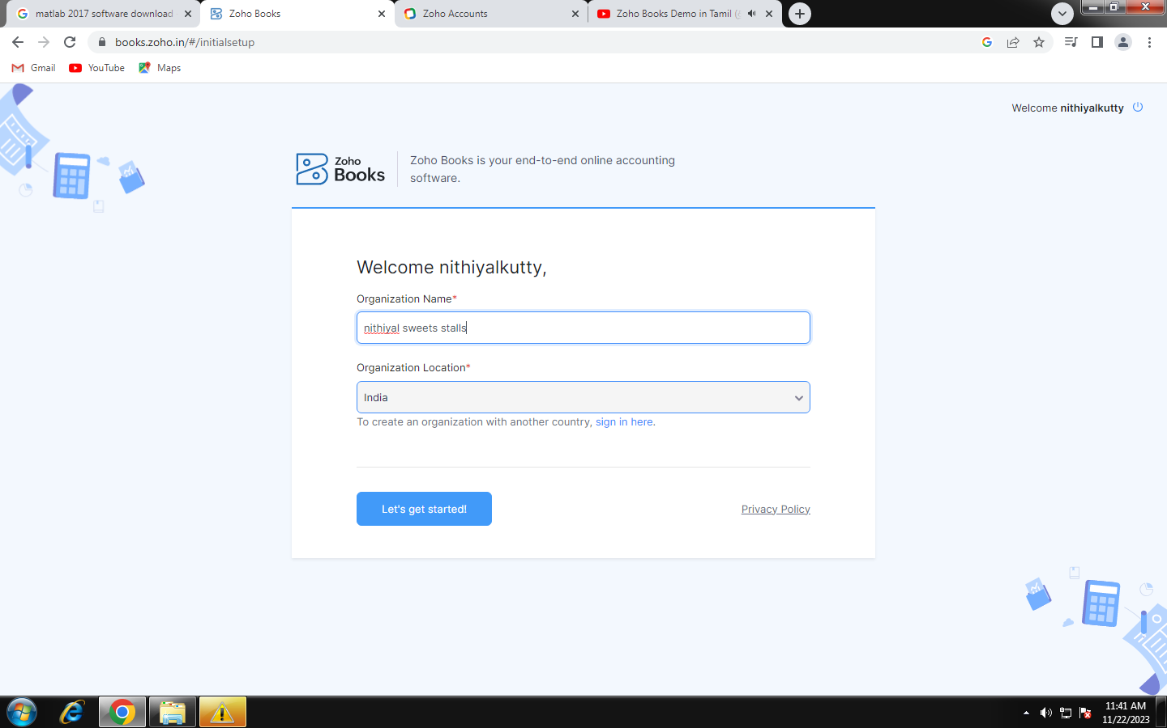

CLICK ON THE GET STARTED BUTTON

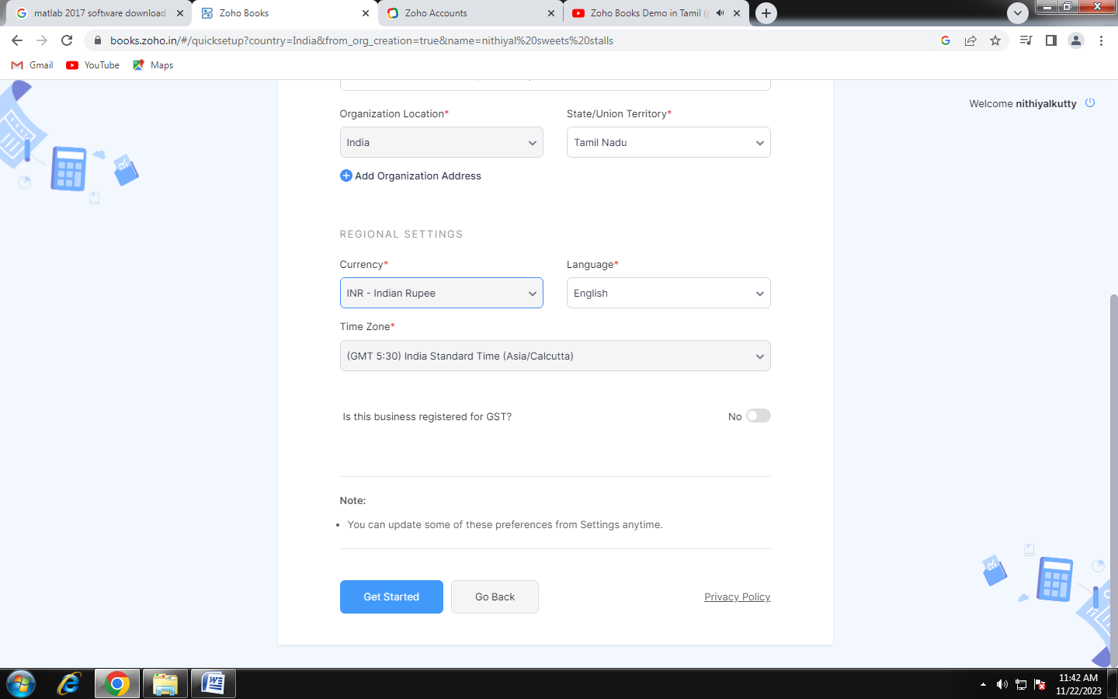

WELCOME TO NITHIYAL SWEETS COMPANY

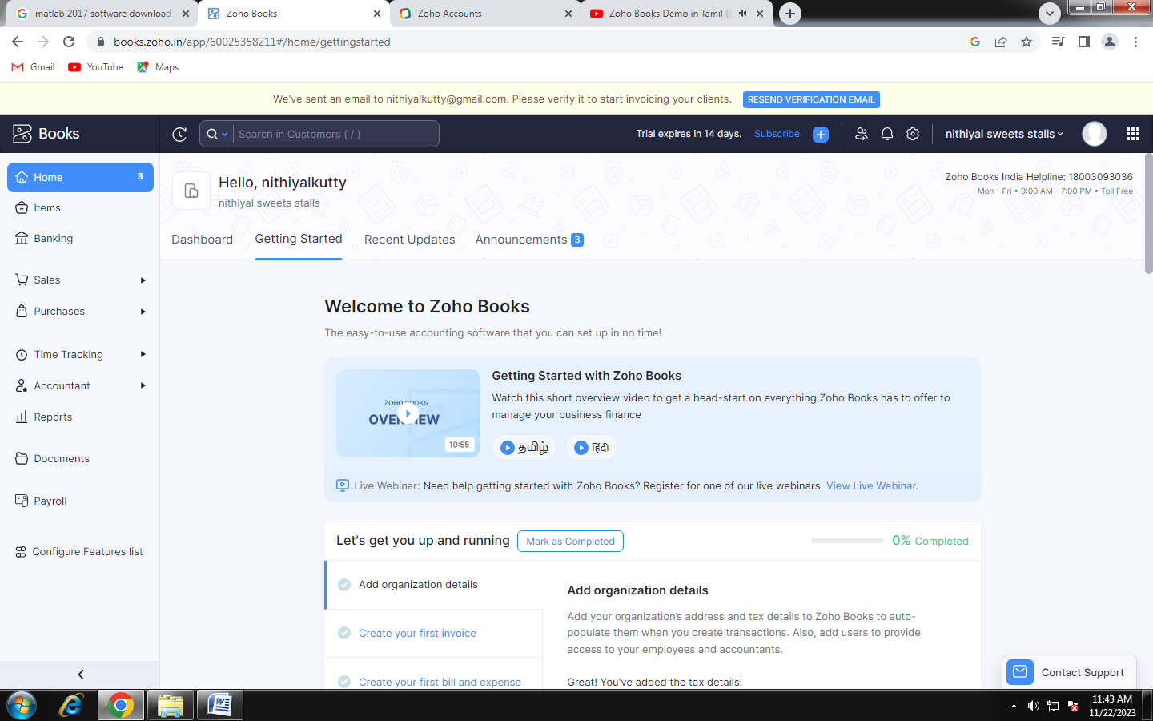

CREATED A ITEMS

